**Practical 2**

**Demonstrate communication between two embedded devices using UART port**

**Steps to Perform:**

**Step 1:** 1) Take Smoke Sensor

2) Take Component - MCU Board

3) Take Alarm

4) Take LCD

**Step 2:** 1) Now we will connect Smoke Sensor to MCU Board with IoT custom cable

connect Smoke Sensor (D0) to MCU Board (D0)

2) Then we will connect MCU Board to Alarm with IoT custom cable connect MCU

Board (D1) to Alarm (D0)

3) Then we will connect MCU Board to LCD with IoT custom cable connect MCU

Board (D2) to LCD (D0)

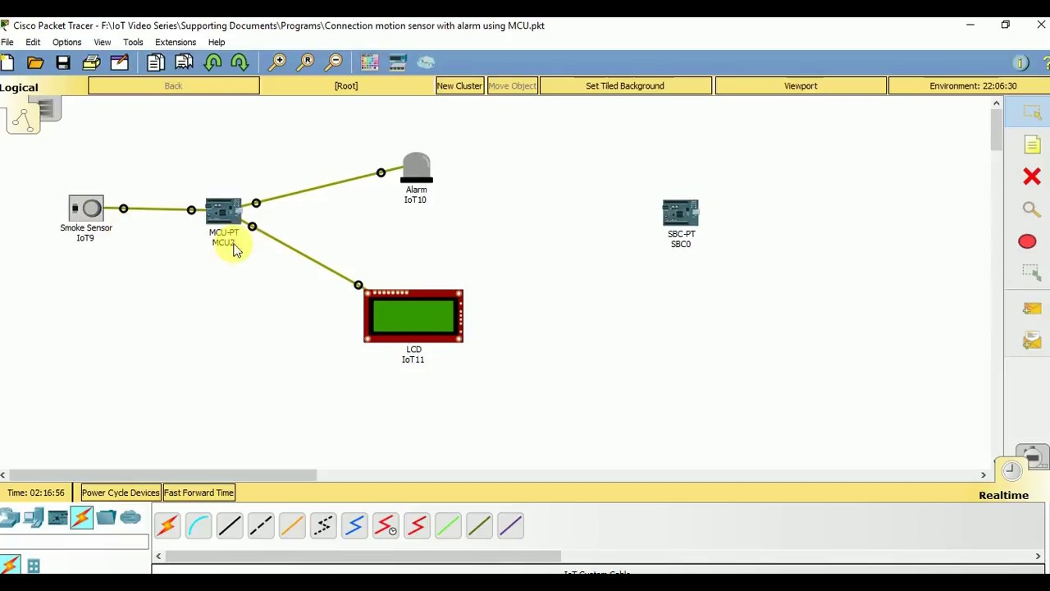

**Step 3:** 1) Now click on MCU Board go to Programming then Select New, Select Template-

Empty-Python then click on Create

2) Click on main.py file then write code